[ZANG] - [Chuanjie]

Student ID: 699382953

[chuanjiezang@gmail.com](mailto:chuanjiezang@gmail.com)

**Assignment 3**

### **All pseudocode in ‘assignment - 3.txt’**

**Part 1.**

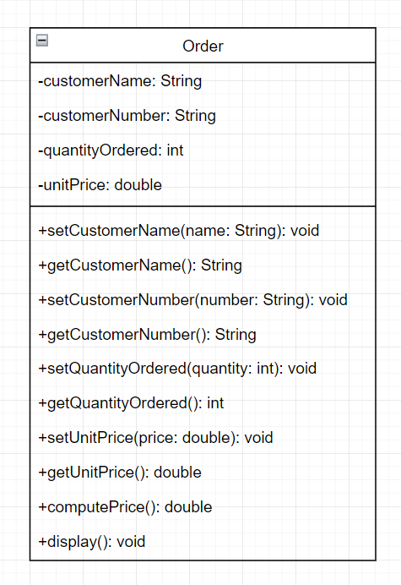

**Part 2.**

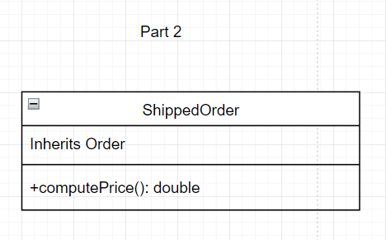

**Part 3.**

### **All pseudocode in ‘assignment - 3.txt’**

Main program ( Main ): It is responsible for process control, creating instances of standard and shipping orders, and getting user input and finally displaying order details.

UserInputForOrder: This is a generic subroutine for getting input for any type of order. It accepts an order object as a parameter (which can be of type Order or ShippedOrder ) and then prompts the user to enter the necessary order information such as customer name, number, quantity and unit price.

Running the process

The user first enters the details of a standard order and the program creates an Order object and displays the results; next, the user enters the information for a shipping order and the program creates a ShippedOrder object and displays the results after adding the additional shipping charges.

**Part 4.**

### **All pseudocode in ‘assignment - 3.txt’**

Main program ( Main ): controls the entire order entry and processing flow. Uses a loop to receive user input until the termination condition is reached.

Order Storage: Uses an array of orders to store each created order object, either Order or ShippedOrder.

Condition Checking: Decide whether to continue receiving orders by checking the customer name entered by the user, or checking if the number of orders already entered reaches 10.

Displaying all orders: After the input is complete, the loop iterates through the orders array, calling the display() method and the computePrice() method for each order to display the order details and the calculated total price.

Running the program

The program will continue to receive order data until the user enters "ZZZ" or until 10 orders have been entered. For each order, an order object is created depending on whether the user chooses shipping or not. All the order information is displayed together at the end, including the details of each order and the total price.